Red Bank Middle School

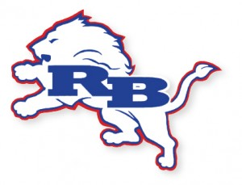
This might be the WEIRDEST SCHOOL YEAR EVER, but we’re still hard at work:
Creating 2 Outdoor Classrooms
Maintaining the Care Closet
& Teacher Appreciation projects!
Become a part of the Red Bank Way,
Join the RBMS PTA!
Your $5 membership dues are an investment in our school’s atmosphere & YOUR student’s experience at RBMS.
There are involvement opportunities to fit your schedule!

-----------------------------------------------------------------------------------------------------
RBMS PTA Member Information

Your name: _______________________________________________________
Email:_____________________________________________________________
Phone number:____________________________________________________
Student’s name:___________________________________________________
Student’s grade :__________________________________________________

